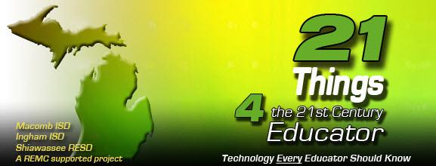
21 Things 4 Teachers

Lesson Plan Template

Direction: Utilize this lesson plan template to create technology infused lessons that integrate best practice.

Creator Name:

School District:

Lesson Title:

Grade Level:

Learning Objectives (list or describe what you want the students to know, understand, or be able to do as a result of the lesson)

Lesson Overview (short description)

Time Frame (number of sessions, length of periods)

Teacher Resources (materials, equipment, technology tools or resources)

Student Resources (materials, equipment, technology tools or resources)

Teacher Preparation (downloads, links, copies, filtering issues)

Teacher Directions For Lesson (procedures and activities)

__________________________________________________________________________
Using the Framework for Instructional Planning
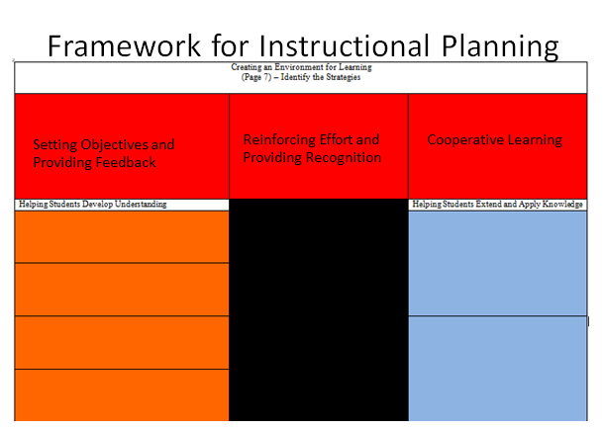
Creating the Environment for Learning (Red Zone)
Directions: Please fill out your reflections for each section of the lesson plan. Indicate how you and/or your students will use technology to help set the environment for learning in one or both of the last two sections.
Providing Feedback: (How will you inform students about their progress toward the objective?)
Providing Recognition: (How will you recognize students who have met the objective?)
Cooperative Learning: (How will students collaborate/support each other during the lesson?)
Teacher use of technology:
Student use of technology:

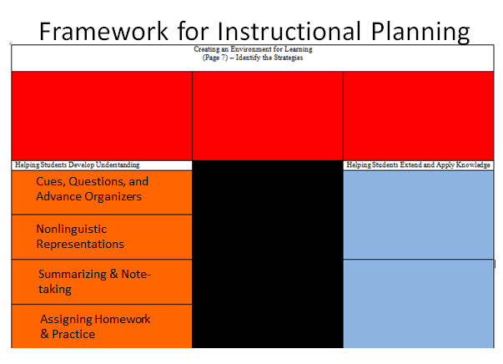
Developing Understanding (Orange Zone)
Directions: Please fill out your reflections for at least two of the four sections below. Indicate how you and/or your students will use technology to help develop understanding in one or both of the last two sections.
Cues, Questions, and Advance Organizers: (What technology resource will you create or use to help cue the learning for the students?)
Non-Linguistic Representation: (What Non-linguistic Representations can you use or can students use to help them understand the concepts)?
Summarizing and Note-Taking: (How will you have students take notes or summarize their learning?)
Assigning Homework and Providing Practice: (What technology resources can you use--e.g. posting on a class site, assigning a video as “homework” to review and reflect, creating a screencast, etc.)
Teacher use of technology:
Student use of technology:
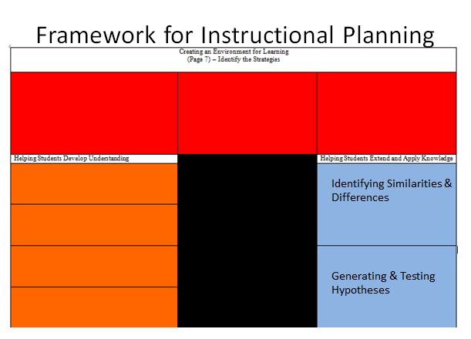
Extending and Applying Knowledge (Blue Zone)
Select one or both of the categories for this section. Explain how you will incorporate this category of best practice into the lesson. Indicate how you and/or your students will use technology to help extend and apply knowledge in one or both of the last two sections.
Identifying Similarities and Differences: (What comparing/classifying, use of metaphors/analogies can you bring into the lesson?)
Generating and Testing Hypotheses: (Explain how students will be involved in one of the four types of activities in Generating and Testing Hypotheses)
Teacher use of technology:
Student use of technology:

__________________________________________________________________________

Assessment/Rubric: share your rubric link for evaluation below and explain any other assessment tools such as polling or survey tools you plan to use with students during the lesson
__________________________________________________________________________

Standards: Curriculum Standards and Technology Integration--please list the NETS for students and the curriculum standards the lesson addresses below.

National Educational Technology Standards:

Core Content National Standards or Michigan State Standards as applicable

__________________________________________________________________________

Creative Commons Information: Create a license using the site for your lesson plan indicating your permissions for sharing.

