The Instructional Technology Departments
at

In collaboration with the
State REMC Association of Michigan
Present

21 Things for the 21st Century Educator
Technology Every Educator Should Know
http://21things4teachers.net
A collaborative project between
Clinton RESA, Ingham ISD, Macomb ISD, Shiawassee RESD and REMC Association of Michigan

Created by:
Carolyn McCarthy, Instructional Technology Consultant
Dr. Jennifer Parker-Moore, Instructional Technology & School Data Consultant
Jan Harding, Interactive Learning Consultant
Melissa White, Instructional Technology & Media Consultant

Course | Dates
Cohort 12 | September, 2013 – April, 2014
All participants will be following the Graduate Course Syllabus, which includes those seeking professional development hours, SCECHs or graduate credits.

EDU 508 Course Title: 21 Things Every 21st Century Educator Should Know (21things4teachers) (1-4 Credit Hours)

Course Description –
Graduate Credits Available through Central Michigan University, SCECHs may be available
The purpose of the 21things for 21st Century Educator (21Things4Teachers) course is to provide ”Just in Time” training through an online interface for K-12 educators based on the National Educational Technology Standards for Teachers (NETS-T) and Administrators (NETS-A). These standards are the basic technology skills every educator should possess. Educators will have the opportunity to develop their own skills, obtain SCHECHs or Graduate Credit, and discover student skills needed to meet Michigan Educational Technology Standards (METS) and Michigan Merit Curriculum Online Experience requirements.

Instructors:
The 21things for the 21st Century Educator web site was created through a collaborative effort between the instructional technologists at Clinton RESA, Macomb ISD, Ingham ISD and Shiawassee RESD and the REMC Association of Michigan. The co-creators, or Project Partners, are as follows:

- Carolyn McCarthy, Clinton RESA/Shiawassee RESD
- Jennifer Parker-Moore, Ed. D., Macomb ISD
- Melissa White, Ingham ISD
- Janice Harding, Macomb ISD

Local Instructors: On file with the University, working as an approved Agency/Agency Coordinator

- Valerie Coffey, Shiawassee RESD/Clinton RESA

- Matinga Ragatz, Eaton ISD
Course Goals
- To tie the use of instructional technology to research based instructional strategies that improve the effectiveness of classroom instruction.
- Michigan Technology and School Improvement Planning and Reporting: Use of the 21things project supports the Michigan Technology plan. The course allows for assessment of professional standards for Michigan teachers' in Personnel Skilled In Technology using the NETS-T and NETS-A rubrics. Educators participate virtually in an online technology course based on curriculum, assessment, and instructional models aligned to the NETS and METS.
- Collaboration to Meet Educator Needs: The 21things for the 21st Century Educator site is a collaborative project designed under a Creative Commons license to fill the needs of educators for web 2.0 technology applications and training. This project helps districts’ bridge the widening gap between students and teachers technology skills. It also provides cost-effective ways to provide professional development, the flexibility of any-time (just-in-time) training, and FREE web tools aligned to state and national standards.
- To assist teachers in meeting the National Educational Technology Standards for Teachers
- To assist school districts in determining “Personnel Skilled in Technology” as required for state reporting
- To expose teachers to an online course as required of Michigan high school students by the Michigan Merit Curriculum online requirement
- To develop teacher proficiency in the integration of Michigan Educational Technology Standards for Students into classroom instruction
- To allow for assessment, critical evaluation, and self-reflection of technology skills as determined by state and national standards
- To provide teachers with differentiated strategies in the area of instructional technology
- To assist teachers in building skill levels to bridge the digital divide

Required Text/Readings:
Participants are expected to complete the readings and activities associated with the 21 online lessons to learn basic technology skills using a variety of web tools in a blended learning environment. Each lesson, or “thing”, includes a “how to” video, hands-on activities, ties to the National Educational Technology Standards (NETS-T) standards, and an overview of how this tool can be used in the classroom. Participants demonstrate proficiency in each of the 21things by creating an end-product, or a Digital Portfolio. Additional readings may be added to the enrich content.
National Educational Technology Standards for Teachers: http://www.iste.org/standards
Effective teaching and learning strategies found in the Using Technology with Classroom Instruction that Works, 2nd ed. (Pitler, Hubbell, Kuhn, 2012).

Participants will be expected to complete all of the readings associated with each “Thing”, found at the following sites:
http://www.21things4teachers.net
On each page of the web site, there are required readings for each of the 21 things elements.

- Introduction to the Course
- Cloud Initiation
- Face of the Classroom (Online Presence)
- Collaboration Tools
- Communication Tools
- Content Area Tools
- Differentiated Instruction & Diverse Learning
- Digital Citizenship
- Visual Learning
- Copyright & Creative Commons
- Digital Images
- Presentation Tools
- Evaluation/Assessment
- Online Interactives
- Productivity Tools
- Staying Informed
- Research & Reference Tools
- Professional Learning Networks
- Virtual Classroom
- Digital Story Telling
- Online Video and Audio Sources
- Flipping Your Classroom (Screen-casting)
Additional Readings:
Dean, C. B., Stone, B., Hubbell, E., & Pitler, H. (2012). Classroom instruction that works: Research-based strategies for increasing student achievement (2nd ed.). Alexandria, VA: ASCD.

Content Standards
Best Practice 9 Categories (Using Technology with CITW)
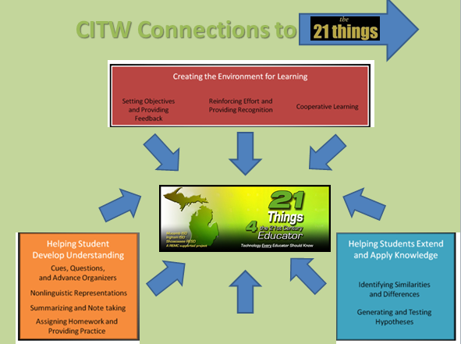

Learning Objectives:
*Know the categories and strategies of the CITW 9
*Understand the classroom recommendations for these strategies
*Make connections between the strategies and technology tools
*Transfer the learning into classroom instruction

NETS-T (Source: http://www.iste.org/standards/nets-for-teachers)
NETS-T (Source: http://www.iste.org/standards/nets-for-teachers)

Effective teachers model and apply the NETS·S as they design, implement, and assess learning experiences to engage students and improve learning; enrich professional practice; and provide positive models for students, colleagues, and the community. All teachers should meet the following standards and performance indicators.

1. Facilitate and Inspire Student Learning and Creativity Teachers use their knowledge of subject matter, teaching and learning, and technology to facilitate experiences that advance student learning, creativity, and innovation in both face-to-face and virtual environments.
a. Promote, support, and model creative and innovative thinking and inventiveness
b. Engage students in exploring real-world issues and solving authentic problems using digital tools and resources
c. Promote student reflection using collaborative tools to reveal and clarify students’ conceptual understanding and thinking, planning, and creative processes
d. Model collaborative knowledge construction by engaging in learning with students, colleagues, and others in face-to-face and virtual environments

2. Design and Develop Digital Age Learning Experiences and Assessments Teachers design, develop, and evaluate authentic learning experiences and assessment incorporating contemporary tools and resources to maximize content learning in context and to develop the knowledge, skills, and attitudes identified in the NETS·S.
a. Design or adapt relevant learning experiences that incorporate digital tools and resources to promote student learning and creativity
b. Develop technology-enriched learning environments that enable all students to pursue their individual curiosities and become active participants in setting their own educational goals, managing their own learning, and assessing their own progress
c. Customize and personalize learning activities to address students’ diverse learning styles, working strategies, and abilities using digital tools and resources
d. Provide students with multiple and varied formative and summative assessments aligned with content and technology standards and use resulting data to inform learning and teaching

3. Model Digital Age Work and Learning
Teachers exhibit knowledge, skills, and work processes representative of an innovative professional in a global and digital society.
a. Demonstrate fluency in technology systems and the transfer of current knowledge to new technologies and situations
b. Collaborate with students, peers, parents, and community members using digital tools and resources to support student success and innovation
c. Communicate relevant information and ideas effectively to students, parents, and peers using a variety of digital age media and formats
d. Model and facilitate effective use of current and emerging digital tools to locate, analyze, evaluate, and use information resources to support research and learning

4. Promote and Model Digital Citizenship and Responsibility
Teachers understand local and global societal issues and responsibilities in an evolving digital culture and exhibit legal and ethical behavior in their professional practices.
a. Advocate, model, and teach safe, legal, and ethical use of digital information and technology, including respect for copyright, intellectual property, and the appropriate documentation of sources
b. Address the diverse needs of all learners by using learner-centered strategies providing equitable access to appropriate digital tools and resources
c. Promote and model digital etiquette and responsible social interactions related to the use of technology and information
d. Develop and model cultural understanding and global awareness by engaging with colleagues and students of other cultures using digital age communication and collaboration tools

5. Engage in Professional Growth and Leadership
Teachers continuously improve their professional practice, model lifelong learning, and exhibit leadership in their school and professional community by promoting and demonstrating the effective use of digital tools and resources.
a. Participate in local and global learning communities to explore creative applications of technology to improve student learning
b. Exhibit leadership by demonstrating a vision of technology infusion, participating in shared decision making and community building, and developing the leadership and technology skills of others
c. Evaluate and reflect on current research and professional practice on a regular basis to make effective use of existing and emerging digital tools and resources in support of student learning
d. Contribute to the effectiveness, vitality, and self-renewal of the teaching profession and of their school and community

Portfolio Work Sheet [Blog Information]
The digital portfolio may take a variety of formats. Check with your instructor/Agency to find out how you will be demonstrating proficiency.
Create a Blog to post your Hands-On Activities and Capstone assignments within the 21things4teachers course. (Sample: Edublogs)
- Things 1-7 Page
  - Create a CATEGORY for Things 1-7, which will result in a PAGE.
  - Complete Hands-On Activities.
    - For each “thing”, complete the hands-on activity found at the web site.
  - Create a Post.
    - Reflection and Screenshot.
      - Using the tools and strategies for best practice instruction, you will be asked to reflect on classroom applications and include images.
    - Post/Publish. Document your completion of each Thing by inserting screen shots and reflections (minimum of 150 words) into your blog for each Thing. (Example: Blog Page for Things 1-7 will include minimum of 7 Posts about the hands-on activities for Things 1, 2, 3, 4, 5, 6, 7).
  - Moderate/Make Comments.
    - Post comments on your fellow classmates’ blogs on a regular basis.
    - Moderate your own comments using this blog feature.
    - Classmate blog addresses are located in BlackBoard or Moodle.
  - Enter Status in BlackBoard/Moodle to indicate it is ready for grading.
    - When you wish your instructor to review your Page, post in the Assignments portion of BB9.1. Your instructor will review your online portfolio and post a grade in BB.
- Things 8-14 Page
  - For posting information, follow the same format as #1 above.
- Things 15-21 Page
  - For posting information, follow the same format as #1 above.
- CITW Connections Page
  - Create a CATEGORY in your blog for CITW connections (9 strategies), which will result in a PAGE.
  - Create a Post.
    - The following posts should be included: 1) setting objectives/providing feedback, 2) reinforcing effort/providing recognition, 3) cooperative learning, 4) cues/questions/advance organizers, 5) non-linguistic representations, 6) summarizing and note-taking, 7) assigning homework and practice, 8) identifying similarities and differences, 9) generating and testing hypothesis
    - Document your understanding of the 9 strategies by making 9 posts on the CITW Connections Page
      - Include a screenshot and reflection about 2-3 tools you learned about during the 21things4teachers course that could support this strategy in your classroom.
      - Include lesson connections where applicable.
  - Moderate/Make Comments.
    - Post comments on your fellow classmates’ blogs on a regular basis.
    - Moderate your own comments using this blog feature.
    - Classmate blog addresses are located in BlackBoard.

Portfolio Work Sheet [Blog Information, cont’d]

- Note: In “Thing 2-Face of the Classroom”, you may also create pages for:
  - About Me
  - Class Information
  - Homework/Assignments
  - Resources

Part A, B, C – Blog Pages and Posts
Create at least 4 pages (1-7, 8-14, 15-21, CITW Connections)
For each “thing”, complete the hands-on activity found at the web site.
Using the tools and strategies for best practice instruction, you will be asked to reflect on classroom applications.
Document your completion by inserting screen shots and reflections into the blog.
Include lesson connections where appropriate. (See Optional Lesson Plan Template)

Edublogs Campus: http://edublogs.misd.net (Macomb only)
Edublogs: http://edublogs.org (Outside Macomb)

If you are using your Blog for your “Thing 2 – Face of the Classroom”, create PAGES for:
- About Me
- Class Information
- Homework Assignments
- Resources

Create blog CATEGORIES to post your “Hands-On Activities” and reflections.
- Things 1-7
- Things 8-14
- Things 15-21
- CITW Connections

Lesson Plan Template
Note: This lesson plan template is one of the options for the Capstone Project.

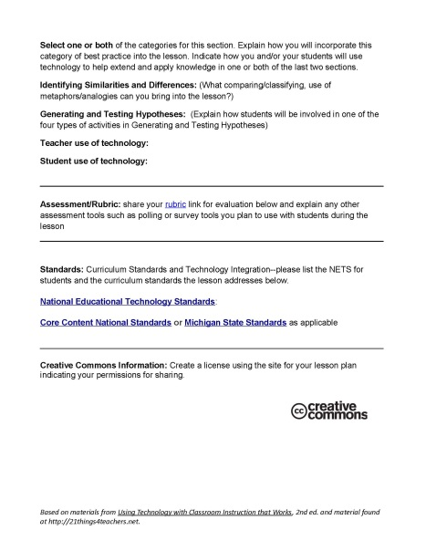
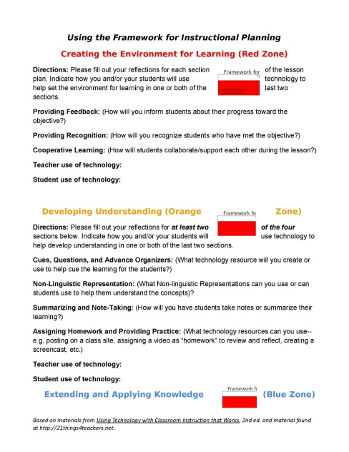
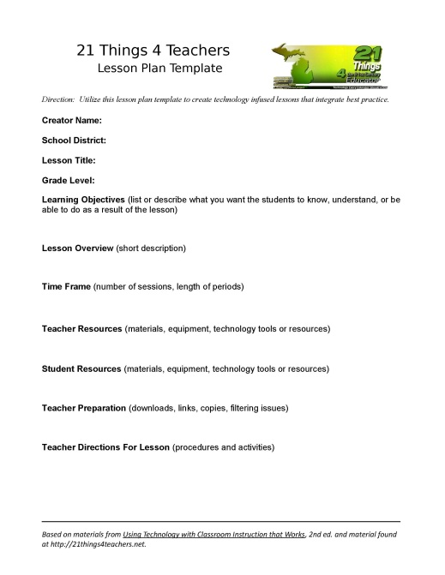
Use the lesson plan template to ensure your technology integration plans align to best practice.
Credit Offerings and Evaluation
Participants have the option of taking this class for 1 credit, 2 credits, 3 credits or 4 credits. All participants are required to attend the first 2 hour session of the semester and then be able to choose the other sessions they attend (based on the content presented) for the appropriate number of hours needed for the credit requirements. Evaluation will be based on meeting the completion of Portfolio, reflection, work log, and virtual session items as determined by the credit option selected.

Participants that choose 1 credit option will have a minimum of 23 contact hours. These would be obtained by:
- Attending Face to Face session
- Attending corresponding Virtual sessions (Things 0-7)
- Attend/complete online sessions (Things 0-7)
- Complete Digital Portfolio with Reflection Journal and Work Log (Things 0-7)

Participants that choose the 2 credit option will have a minimum of 36 contact hours. These would be obtained by:
- Attending Face to Face session
- Attending corresponding Virtual sessions (Things 0-10)
- Attend/complete online sessions (Things 0-10)
- Complete Digital Portfolio with Reflection Journal and Work Log (Things 0-10)

Participants that choose the 3 credit options will have a minimum of 47 contact hours. These would be obtained by:
- Attending Face to Face session
- Attending corresponding Virtual sessions (Things 0-15)
- Attend/complete online sessions (Things 0-15)
- Complete Digital Portfolio with Reflection Journal and Work Log (Things 0-15)

Participants that choose the 4 credit options will have a minimum of 62 contact hours. These would be obtained by:
- Attending Face to Face session
- Attending corresponding Virtual sessions (Things 0-21)
- Attend/complete online sessions (Things 0-21)
- Complete Digital Portfolio with Reflection Journal and Work Log (Things 0-21)

Evaluation Criteria (1, 2, 3, 4 credit option)
The course grade will be a letter grade, minimum for an A is 90%, a B is 80%, a C is 70%, a D is 60%, and below is failing.
SAMPLE:
- 40 points Attendance/Work Log/Participation (11%)
- 210 points Digital Portfolio of Content (21things) (60%)
- 100 points Capstones (29%)
- 350 points Total points awarded (100%)
All evaluations will be based on the NETS•T National Educational Technology Standards for Teachers
NETS•T I Technology Operations and Concepts
NETS•T II Planning and Designing Learning Environments and Experiences
NETS•T III Teaching, Learning, and the Curriculum
NETS•T IV Assessment and Evaluation
NETS•T V Productivity and Professional Practice
NETS•T VI Social, Ethical, Legal, and Human Issues
Credits | Minimum Requirements  Portfolio and Reflections items | Minimum Requirements Work Log items | Recommended Minimum Proficiency for each Thing
1 credit | Things 0-7 | Things 0-7 | Proficient
2 credits | Things 0-10 | Things 0-10 | Proficient
3 credits | Things 0-15 | Things 0-15 | Proficient
4 credits | Things 0-21 | Things 0-21 | Proficient

In determining proficiency for each Thing, the following equivalents are presented to determine performance.
Item/Source | Score | Score | Score | Score | Score
Lickert Scale | 1 | 2 | 3 | 4 | 5
Grading Scale Percent | 0-59% | 60-69% | 70-79% | 80-89% | 90-100%
Grading Scale Grade | E | D | C | B | A
Rubric Description | Not familiar with tool, No knowledge | Beginning Awareness, Know what it is/haven’t used it, Limited knowledge | Awareness, Somewhat experienced and worked with it a few times, Somewhat knowledgeable | Active Awareness, Experienced and proficient user, Very knowledgeable | Flexible Awareness, the integration of multiple tools at a high level of functionality
NETS-T Performance Proficiency | ------ | Beginning | Developing | Proficient | Transformative

Evaluation Criteria: (SAMPLE)
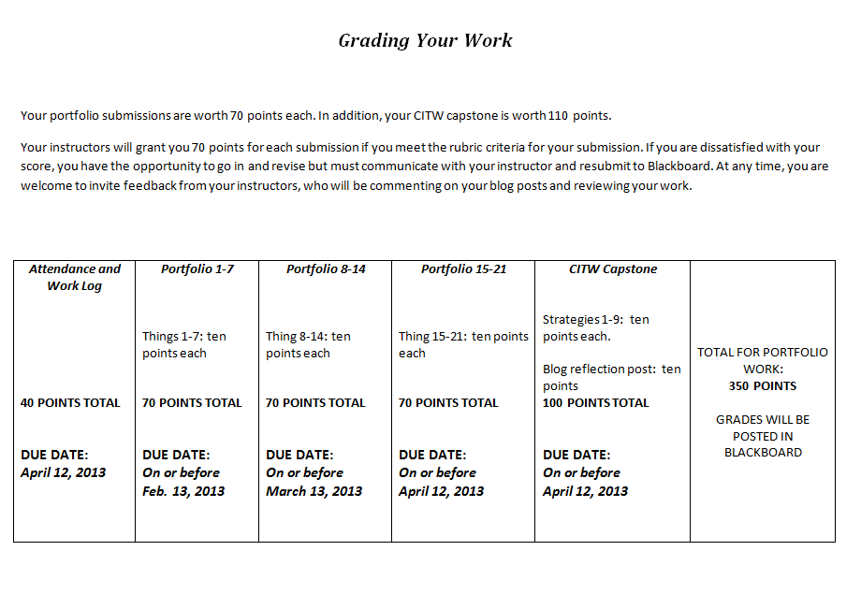
SAMPLE

21things Submission Instructions
SUBMIT THIS PAGE
REQUIRED SUBMISSIONS
IMPORTANT: For participants to earn SCECH’S, they must complete and log the minimum required hours for the entire program as required by the Michigan Department of Education (MDE). This means attending all sessions according to the approved schedule including arriving on time and remaining for the duration of each session. The MDE and MISD review all programs and monitor attendance. Failure to comply with program requirements, including attendance and completion of this portfolio will result in disallowance of SCECH credit. In order to be granted credit, required elements:
- Complete requirements for online portfolio/blog and submit. You may monitor performance and submissions within (BlackBoard (MISD) found at http://bb91.misd.net or at http://edublogs.misd.net
- Complete and Sign Work Log/Time Log with actual logged hours to meet or exceed minimum required hours. This log includes mandatory attendance at the Face to Face session, and active participation in the online sessions to complete all 21things.
- Indicate Preference: I am taking this course for (select one):
Professional Development Hours  Submit time log and portfolio release to MISD. | SCECHS  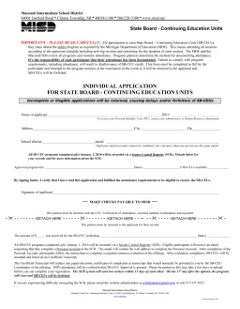  Complete the SCECH application form found on the http://21things1.weebly.com site and make check payable to MISD. Submit time log, portfolio release, SCECH application form, and payment to MISD.
Graduate Credits CMU  Submit your course registration materials and payment from packet given out at Face-to-Face to CMU. Submit time log/portfolio release to MISD. Questions, contact Katie Warren, warre1kd@cmich.edu | Incomplete students should work with their instructor.

- Upon completion of the course, submit log sheets, SCECH application w/ payment (if applicable) by April 11, 2014 to:
Cathy White
Macomb Intermediate School District
Please make checks payable to Macomb ISD
Department of Instructional Technology
44001 Garfield Rd.
Clinton Township, MI 48038

ALL DOCUMENTS MUST BE RECEIVED by April 11, 2014. Remember to make a copy of your documents for your records. Original forms with signatures must be mailed in. Only the portfolio/blog may be submitted digitally.

Name (please print)
Address/City/Zip
School/District /
Signature PIC # _________________________________
I understand that any deviation from this criterion will result in my loss of SB-CEU credit.
SB-CEU Program #: Will be given out upon completion Program Title: 21things for the 21st Century Educator
Beginning Date: September 18, 2013 Ending Date: April 11, 2014

Work Log
Work Log/Time Log [Launch and Adobe Connect Sessions]
SUBMIT THIS PAGE
NOTE: THIS IS VERIFICATION OF YOUR ATTENDANCE
Use this page to keep track of hours per session. You must meet the minimum contact hours and submit this log at the end of the course as verification of your attendance. Virtual Classroom URL: http://remc.adobeconnect.com/twenty1thingsroom
Topic | Dates | Contact Hours | Logged Hours
*21THINGS LAUNCH*  Thing 0 – An Introduction to the Course  (REQUIRED: Face to Face meeting)  (Scheduled by your Agency (ISD/RESA/RESD) – please check CourseWare for updates.) | SELECT LOCATION  *On site by Agency  September 18 @ MISD  4:30 – 7:30 pm | 3
Adobe Connect (Online) Session 1  Thing 1: Cloud Computing | October 2, 2013  4:30 -5:30 pm | 1
Adobe Connect (Online) Session 2  Thing 2: Face of the Classroom | October 9, 2013  4:30 -5:30 pm | 1
Adobe Connect (Online) Session 3  Thing 3: Collaboration; and 4: Communication | October 16, 2013  4:30 -5:30 pm | 1
Adobe Connect (Online) Session 4  Thing 5: Content Area Tools | October 23, 2013  4:30 -5:30 pm | 1
Adobe Connect (Online) Session 5  Thing 6: Differentiated Instruction & UDL | October 30, 2013  4:30 -5:30 pm | 1
Adobe Connect (Online) Session 6  Thing 7: Digital Citizenship | November 6, 2013  4:30 -5:30 pm | 1
Adobe Connect (Online) Session 7  Things 8: Visual Learning; and  Thing 9: Copyright & Creative Commons | November 13, 2013  4:30 -5:30 pm | 1
Adobe Connect (Online) Session 8  Thing 10: Digital Images | November 20, 2013  4:30 -5:30 pm | 1
Adobe Connect (Online) Session  Q & A | December 4, 2013  4:30 – 5:30 pm | 1
Things 0-10 due (No Capstone) | December 13, 2013 | ----
Adobe Connect (Online) Session 10  Thing 11: Presentation Tools | January 8, 2014  4:30 – 5:30 pm | 1
Adobe Connect (Online) Session 11  Thing 12: Evaluation & Assessment | January 15, 2014  4:30 – 5:30 pm | 1
Adobe Connect (Online) Session 12  Thing 13: Interactive Learning; and  Thing 14: Productivity Tools | January 22, 2014  4:30 – 5:30 pm | 1
Adobe Connect (Online) Session 13  Thing 15: Staying Informed | January 29, 2014  4:30 – 5:30 pm | 1
Adobe Connect (Online) Session 14  Thing 16: Research & Reference Tools | February 5, 2014  4:30 – 5:30 pm | 1
Adobe Connect (Online) Session 15  Thing 17: Professional Learning Networks | February 12, 2014  4:30 – 5:30 pm | 1
Adobe Connect (Online) Session 16  Thing 18: Virtual Classroom | February 19, 2014  4:30 – 5:30 pm | 1
Adobe Connect (Online) Session 17  Thing 19: Digital Storytelling | February 26, 2014  4:30 – 5:30 pm | 1
Adobe Connect (Online) Session 18  Thing 20: Online Video & Audio | March 5, 2014  4:30 – 5:30 pm | 1
Adobe Connect (Online) Session 19  Thing 21: Flipping the Classroom | March 19, 2014  4:30 – 5:30 pm | 1
Adobe Connect (Online) Session 20  Q & A, Capstone Activity | March 26, 2014  4:30 – 5:30 pm | 1
Things 11-21; Capstones due | April 11, 2014  4:30 – 5:30 pm | ----
SUBTOTAL: virtual and face to face classes |  | 23

Work Log/Time Log [Hands-On Activities]
SUBMIT THIS PAGE
* NOTE: THIS IS VERIFICATION OF YOUR ATTENDANCE
Use this page to keep track of hours per session. You must meet the minimum contact hours and submit this log at the end of the course as verification of your attendance. Hands On Activities found at: http://www.21things4teachers.net or within your Course Management System ([Moodle, Blackboard, etc.])
Online Sessions | Activities | Time Guide  [Minimum] | Logged Hours
Cloud Initiation | *Review of “Thing”  *Review of Web Tools that support “Thing”  *View video or tutorial  *Application of NETs for Teachers  using Web Tool(s)  *Complete Assignment and Portfolio reflection | 3 hours
Face of Your Classroom | *Review of “Thing”  *Review of Web Tools that support “Thing”  *View video or tutorial  *Application of NETs for Teachers  using Web Tool(s)  *Complete Assignment & Portfolio reflection | 3 hours
Collaboration Tools | *Review of “Thing”  *Review of Web Tools that support “Thing”  *View video or tutorial  *Application of NETs for Teachers  using Web Tool(s)  *Complete Assignment & Portfolio reflection | 3 hours
Communication Tools | *Review of “Thing”  *Review of Web Tools that support “Thing”  *View video or tutorial  *Application of NETs for Teachers  using Web Tool(s)  *Complete Assignment & Portfolio reflection | 3 hours
Content Area Tools | *Review of “Thing”  *Review of Web Tools that support “Thing”  *View video or tutorial  *Application of NETs for Teachers  using Web Tool(s)  *Complete Assignment & Portfolio reflection | 3 hours
Differentiated Instruction & Diverse Learning | *Review of “Thing”  *Review of Web Tools that support “Thing”  *View video or tutorial  *Application of NETs for Teachers  using Web Tool(s)  *Complete Assignment & Portfolio reflection | 3 hours
Digital Citizenship | *Review of “Thing”  *Review of Web Tools that support “Thing”  *View video or tutorial  *Application of NETs for Teachers  using Web Tool(s)  *Complete Assignment & Portfolio reflection | 3 hours
Visual Learning | *Review of “Thing”  *Review of Web Tools that support “Thing”  *View video or tutorial  *Application of NETs for Teachers  using Web Tool(s)  *Complete Assignment & Portfolio reflection | 3 hours
Copyright & Creative Commons | *Review of “Thing”  *Review of Web Tools that support “Thing”  *View video or tutorial  *Application of NETs for Teachers  using Web Tool(s)  *Complete Assignment & Portfolio reflection | 3 hours

Online Sessions | Activities | Time Guide  [Minimum] | Logged Hours
Digital Images | *Review of “Thing”  *Review of Web Tools that support “Thing”  *View video or tutorial  *Application of NETs for Teachers  using Web Tool(s)  *Complete Assignment & Portfolio reflection | 3 hours | SUBMIT THIS PAGE
Presentation Tools | *Review of “Thing”  *Review of Web Tools that support “Thing”  *View video or tutorial  *Application of NETs for Teachers  using Web Tool(s)  *Complete Assignment &Portfolio reflection | 3 hours
Evaluation & Assessment Tools | *Review of “Thing”  *Review of Web Tools that support “Thing”  *View video or tutorial  *Application of NETs for Teachers  using Web Tool(s)  *Complete Assignment & Portfolio reflection | 3 hours
Online Interactive Learning Tools | *Review of “Thing”  *Review of Web Tools that support “Thing”  *View video or tutorial  *Application of NETs for Teachers  using Web Tool(s)  *Complete Assignment & Portfolio reflection | 3 hours
Productivity Tools | *Review of “Thing”  *Review of Web Tools that support “Thing”  *View video or tutorial  *Application of NETs for Teachers  using Web Tool(s)  *Complete Assignment & Portfolio reflection | 3 hours
Staying Informed | *Review of “Thing”  *Review of Web Tools that support “Thing”  *View video or tutorial  *Application of NETs for Teachers  using Web Tool(s)  *Complete Assignment & Portfolio reflection | 3 hours
Research & Reference Tools | *Review of “Thing”  *Review of Web Tools that support “Thing”  *View video or tutorial  *Application of NETs for Teachers  using Web Tool(s)  *Complete Assignment & Portfolio reflection | 3 hours
Professional Learning Networks | *Review of “Thing”  *Review of Web Tools that support “Thing”  *View video or tutorial  *Application of NETs for Teachers  using Web Tool(s)  *Complete Assignment &Portfolio reflection | 3 hours

Online Sessions | Activities | Time Guide  [Minimum] | Logged Hours  SUBMIT THIS PAGE
Virtual Classroom | *Review of “Thing”  *Review of Web Tools that support “Thing”  *View video or tutorial  *Application of NETs for Teachers  using Web Tool(s)  *Complete Assignment &Portfolio reflection | 3 hours
Digital Story Telling | *Review of “Thing”  *Review of Web Tools that support “Thing”  *View video or tutorial  *Application of NETs for Teachers  using Web Tool(s)  *Complete Assignment & Portfolio reflection | 3 hours
Online Video & Audio Resources | *Review of “Thing”  *Review of Web Tools that support “Thing”  *View video or tutorial  *Application of NETs for Teachers  using Web Tool(s)  *Complete Assignment & Portfolio reflection | 3 hours
Flipping Your Classroom: Screen-casting | *Review of “Thing”  *Review of Web Tools that support “Thing”  *View video or tutorial  *Application of NETs for Teachers  using Web Tool(s)  *Complete Assignment & Portfolio reflection | 3 hours
SUBTOTAL Hands-On/Online Activities Hours |  | 63 hours
Capstone Projects | *Making Lesson Plan Connections to the Using Technology with Classroom Instruction that Works framework | 4 hours
SUBTOTAL Capstone Activities |  | 4 hours
TOTAL |  | 90 hours

Course ends April 11, 2014

This is to certify that the 21things Portfolio and the logged hours are an accurate reflection of my time on
the project.

Signature: _____________________________________

SUBMIT THIS PAGE
Project Partners for 21things for the 21st Century Educator
21 Things for the 21st Century Educator
Use of Participant’s Work/Portfolio

Dear Participant:
As part of “21 Things for the 21st Century Educator” we would like permission to publish portions of your portfolio online as an example of excellent work. Note that these pages include your name and district. We would also like permission to circulate your completed portfolio during face-to-face trainings to incoming participants. Signing this form officially documents that you will allow the use of your portfolio for instructional and demonstration purposes within the context of the "21Things for the 21st Century Educator” course. There is no monetary compensation for the use of your work.
I release the Clinton RESA, Macomb ISD, Shiawassee RESD, Ingham ISD, and/or partnering agency in providing the course and their Board of Education, the individual members, agents and employees and representatives from financial consideration, pertaining to these projects or images. I promise not to initiate a lawsuit in any court of the United States to compel, enjoin or enforce legal claims which I have waived by execution of this Agreement.
This release includes, but is not limited to, my waiver of all proceeds or advantages derived from the reproduction or publication of my work.

Print Name District/School

Dated:
Signature

Please sign and submit with final course requirements by due date.

